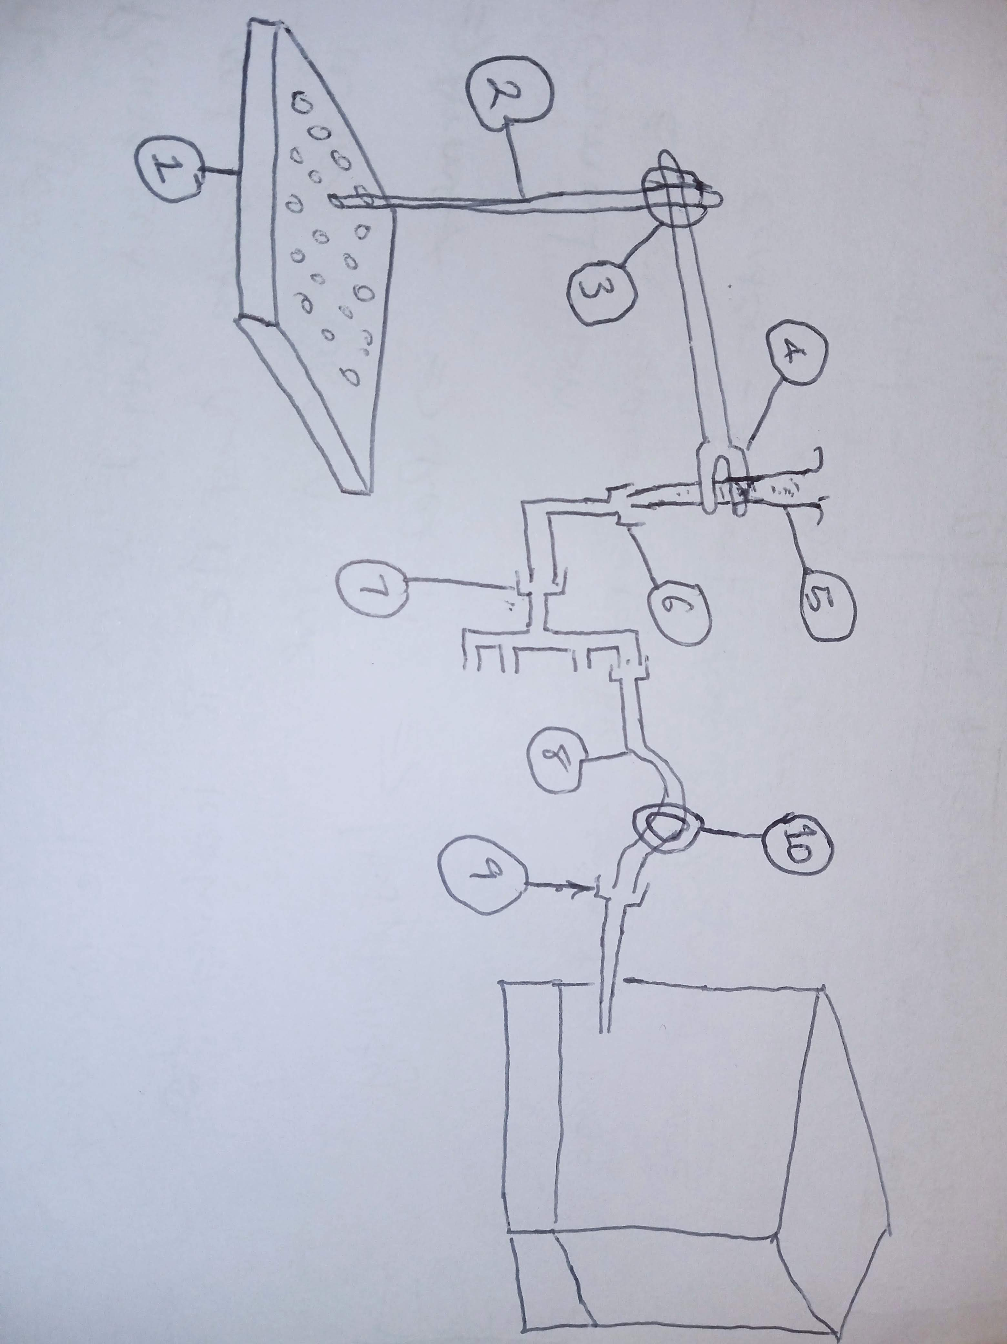Diagram Key:

1. Thor labs base (1pc small size)
2. Stands
3. Stand Connectors
4. Syringe clamp
5. ~~Syringe~~ (In stock)
6. Syringe to tubing connector
7. One way to 4-way connector
8. ~~Tubing~~ (In stock)
9. Tubing to syringe connector.
10. Solenoid valve